**DATA ANALYSIS WITH PYTHON**

Importing Datasets

1. Price: Target value/label
   1. Price is the value to predict from the dataset
   2. The predictors are all the other variables

Python Packages

1. Python Library: Collection of functions and methods that allow you to perform lots of actions without writing any code
2. Contain built in modules providing different functionalities you can use directly
3. Scientific Computing Libraries
   1. Pandas: Data structure and tools for data manipulation and analysis. Fast access to structured data. Primary instrument of pandas is a two dimensional table consisting of column and row labels – called a dataframe. Designed to provide easy functionality
   2. Numpy: Uses arrays for input and outputs. Extended to objects for matrices. With minor coding changes, developers can perform fast array processing
   3. SciPy: Functions for some advanced maths problems. Integrals, solving differential equations and optimization. Data visualization.
4. Visualization Libraries
   1. Matplotlib: Plots and Graphs
   2. Seaborn: Heat maps, time series, violin plots
5. Algorithmic Libraries: Machine learning models – obtain prediction
   1. Scikit-learn: Machine learning, regression and classification. Built on Numpy, SciPy and Matplotlib
   2. Statsmodels: Explore data, estimate statistical models and perform statistical tests

Importing and Exporting Data in Python

1. Data Acquisition: Process of loading and reading data into Python from various resources
2. Two important factors when reading data into Pandas
   1. Format: Encoding (csv, json, xlsx, hdf)
   2. File Path: Where the data is stored
3. Importing data in pandas – three lines
   1. Import pandas as pd
   2. Define variable with a file path (url = [https://](NULL))
   3. Df = pd.read_csv(url)
4. Importing a CSV without a header
   1. Df = pd.read_csv (url, header = None)
5. Printing the Dataframe in Python
   1. Df prints the entire dataframe (not recommended for large datasets)
   2. Df.head() to show first *n* rows of data frame
   3. Df.tail() show the bottom *n* rows of data frame
6. Adding Headers
   1. Replace default header (df.columns = headers) 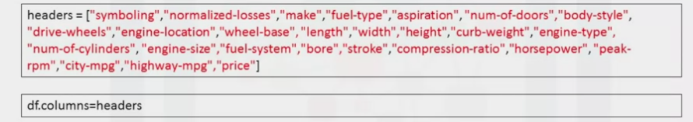
7. Exporting a Pandas dataframe to CSV
   1. Path = “c:/windows/…/automobile.csv”
   2. Df.to_csv (path)

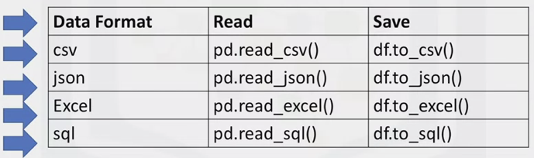

Getting Started Analyzing Data in Python

1. Should check:
   1. Data types
   2. Data distribution
   3. Locate potential issues with the data
2. Data Types stored between native Python and pandas

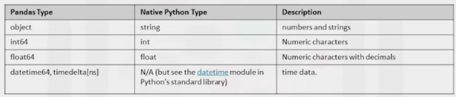

1. Why check data types? – Pandas automatically assigns types based on the encoding from the original table
   1. Potential info and type mismatch
   2. Compatibility with python methods (which functions can be applied to a specific column)
2. Return a statistical summary
   1. Df.describe()
      1. Extreme outliers or large deviations
   2. Dataframe.describe(include=”all”)
      1. Provides full summary statistics
   3. Df.info()
      1. Shows the top and bottom 30 rows of a data frame
   4. Df.dtypes

Accessing Data with Python

* + - 1. USER – JUPYTER NOTEBOOK – API CALLS – DBMS
      2. SQL API’s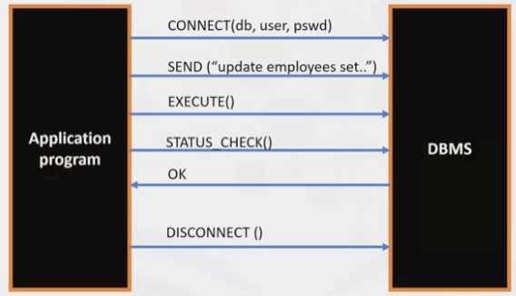
         1. To send a SQL statement to the DBMS, the program builds a text string in a buffer and makes an API call to pass the buffer contents to the DBMS
         2. The app makes API calls to check the status of the DBMS and to handle errors
         3. Disconnects with an API call
      3. What is DB_API?
         1. Python standard API for accessing relational databases
         2. Allows you to work with multiple kinds of relational databases

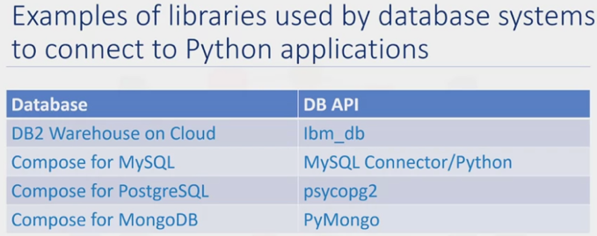

* + - 1. Concepts of the Python DB API
         1. Connection Objects

Database connections

Manage transactions

* + - * 1. Cursor Objects

Database queries

* + - 1. What are Connection Methods?
         1. Cursor() – returns a new cursor object using the connection
         2. Commit() – Commit any pending transaction to the database
         3. Rollback() – Causes the database to rollback to the start of any pending transaction
         4. Close() – close a database connection

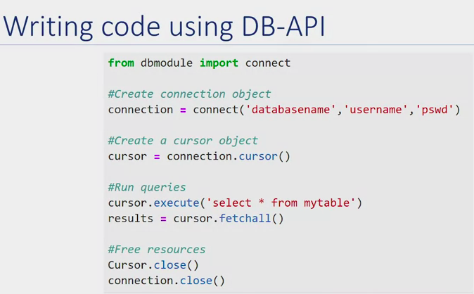

Data Wrangling

1. Data-Preprocessing: The process of converting or mapping data from the initial “raw” form into another format, in order to prepare the data for further analysis
   1. A.K.A Data cleaning, Data Wrangling
   2. Identify and handle missing values: Error occur whenever a data value is left empty
   3. Data formatting: Data from different formats, in different units or conventions
   4. Data Normalization (centering/scaling): Way to bring all data into a similar range for useful comparison
   5. Data Binning: Create bigger categories from a set of numerical values.
   6. Turning Categorical values into numeric variables
2. Df[“symbolling”]=df[“symbolling”]+1

Dealing with Missing Values in Python

1. When no data is stored for a variable in an observation
   1. Represented as “?”, “N/A”, 0 or just a blank
2. How to deal with missing values?
   1. Check with the data collection source: Can the collector go back and find what the missing value should be
   2. Drop the missing values
      1. Drop the variable
      2. Drop the data entry
   3. Replace the missing values with an average of the entire variable
      1. Replace it with an average (of similar datapoints)
      2. Replace it by frequency
      3. Replace it based on other functions
   4. If the variable value is not a number (e.g. fuel type) try using the mode “most common”
   5. Consult the data gatherer
   6. Leave it as missing data
3. How to Drop Missing Values
   1. Dataframes.dropna() = pandas

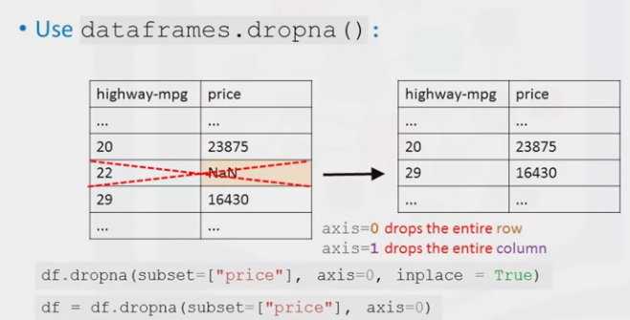df.dropna(subset=[“price”], axis=0) – this does not change the dataframe, but is a good way to ensure you are performing the correct operation. Must use (inplace = True)

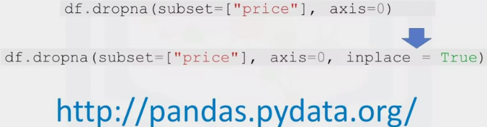

1. How to replace missing values in Python
   1. Dataframe.replace(missing_vaues, new_value)

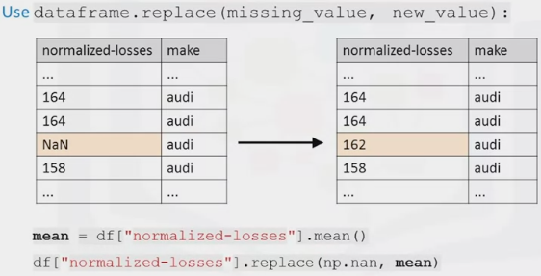

Data Formatting in Python

1. Bringing data into a common standard of expression allows users to make meaningful comparison

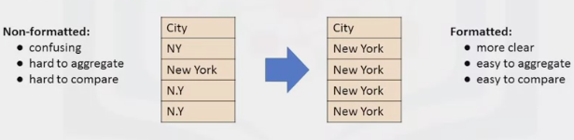

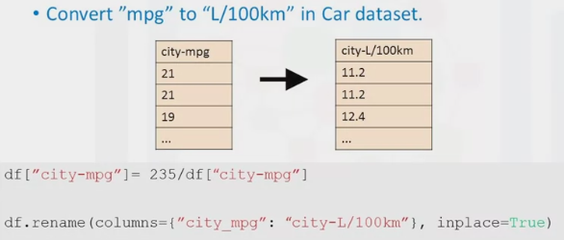

1. Incorrect Datatypes
   1. Often the wrong data type is assigned to a feature

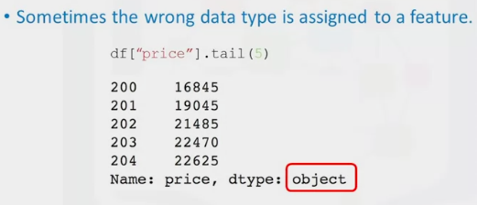Should be a integer or float

1. Correcting data types
   1. Identify: dataframe.types()
   2. Convert: dataframe.astype()
      1. Df[“price”] = df[“price”].astype[“int’]

Data Normalization

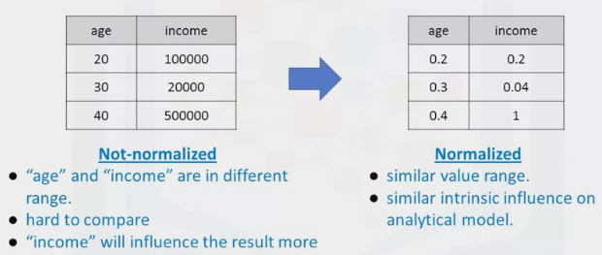

1. Approaches to normalize data
   1. Simple Feature scaling: Divides each value by the maximum value for that feature. Makes the new values range between 0-1
   2. Min-Max: Takes each value, subtracts it from the minimum value of that feature and divides by the range of that feature. Range: 0-1
   3. Z-Score/Standard-Score: For each value you subtract the average of the feature and then divide by the standard deviations (Sigma). Range between -3 and +3

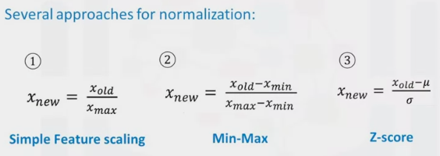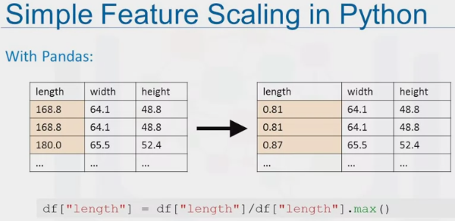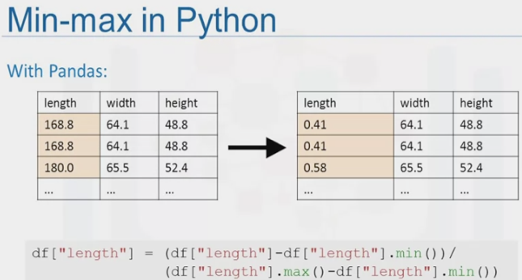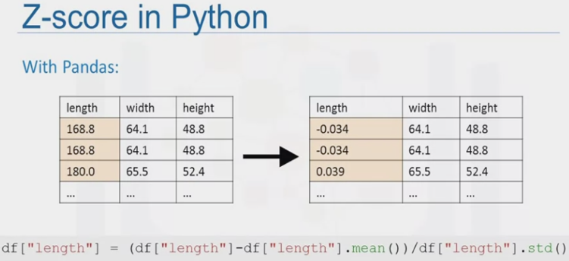

Binning in Python

1. Grouping of values into “bins”
   1. Age: 0-5, 6-10, 11-5
2. Can improve accuracy in the data models
3. Converts numeric into categorical variables
   1. Smaller number of bins gives a greater understanding of distribution
4. Group a set of numerical values into a set of “bins”

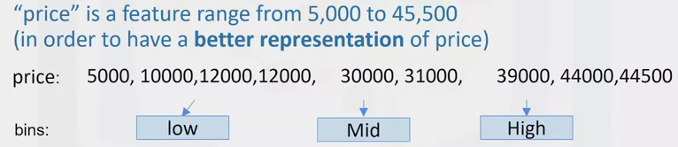

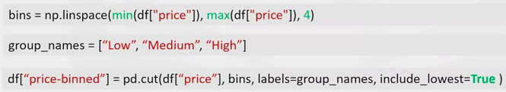

* 1. Np.linspace to return 4 equally spaced numbers over the specified interval of the price
  2. Create group_names that contain the bin names
  3. Pd.cut to segment and sort the data values into bins

1. Histograms to visualize the data once it has been plotted

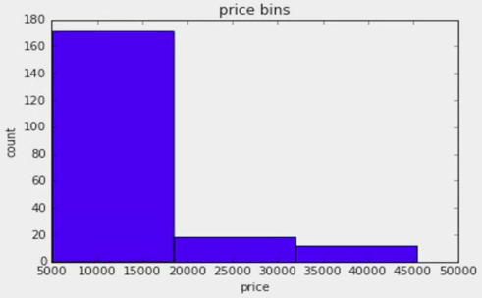

Turning Categorical Variables into Quantitative Variables in Python

1. Most statistical models cannot take in the objects/strings as input
2. Assign 0 or 1 in each category

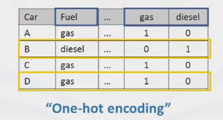

1. In pandas we use get_dummies() method
   1. Convert categorical variables to dummy variables (0 or 1)

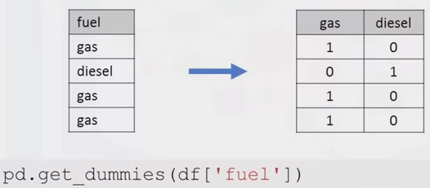

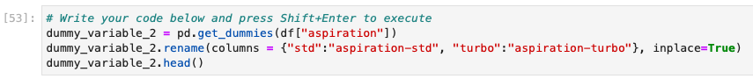





**EXPLORATORY DATA ANAYSIS**

1. Preliminary step in Data Analysis to:
   1. Summarize main characteristics of the data
   2. Gain better understanding of the data set
   3. Uncover relationships between variables
   4. Extract important variables

Descriptive Statistics

1. Describes basic features of a dataset
2. Gives a short summary about samples and measure of the data
   1. Pandas describe() method: Shows the mean, total no. of data point, standard deviation quartiles and the extreme values. NaN values skipped.
   2. Value_counts() – Summarize the categorical data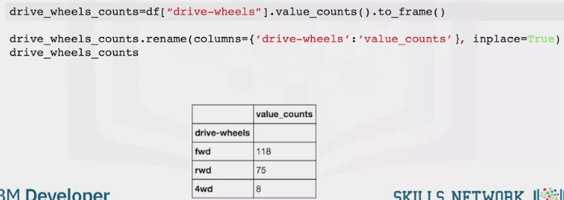
   3. Box Plots: sns.boxplot

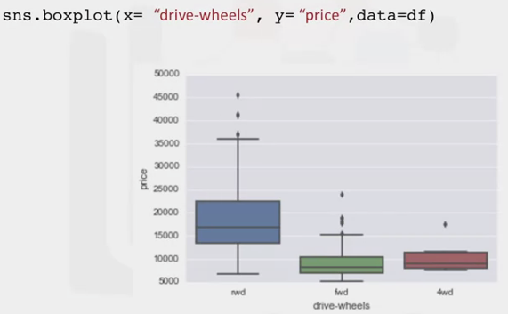

* 1. Scatter Plot: Relationship between two variables
     1. Predictor/independent variable on x-axis
     2. Target/dependent variable on the y-axis
     3. Label your axis and provide a heading!

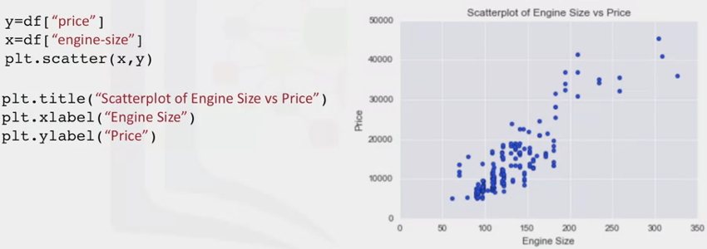

Groupby in Python

1. Dataframe.groupby()
   1. Can be applied on categorical variables]
   2. Group data into categories
   3. Single or multiple variables

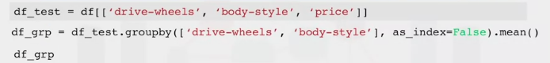

1. Pandas method – pivot() – helps to visualize the results of groupby

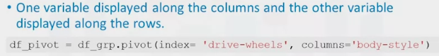

1. Heatmap
   1. Takes a rectangular grid of data and assigns a color intensity based on the data value at the grid points
   2. Convert the previous pivot table into a graphical form
   3. Cmap(rdbu)

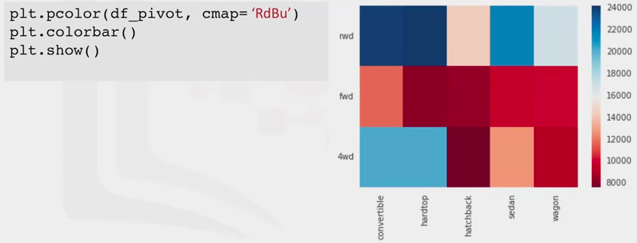

Correlation

1. Correlation is a statistical metric for measuring to what extent different variables are interdependent
   1. Over time, if one variable changes, how does this affect change in the other variables
2. Correlation doesn’t imply causation
   1. E.g. Rain and umbrella are correlated, but rain does not cause the umbrella
3. Visualize the two variables using a scatter plot with a regression line – which indicate the relationship between the variables – seaborn regplot

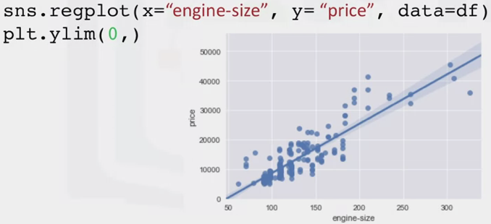

Positive Linear Relationship

Correlation – Statistics

1. Pearson Correlation: Measure the strength of correlation between two features:
   1. Correlation coefficient
      1. +1 Large positive relationship
      2. -1: Large negative relationship
      3. 0: No relationship
   2. P-value: How certain we are about the correlation calculated
      1. <0.001 Strong certainty
      2. <0.05 Moderate
      3. <0.1 Weak certainty
      4. >0.1 no certainty
2. Strong correlation = correlation coefficient close to 1or -1 / p value <0.001
3. Using SciPy

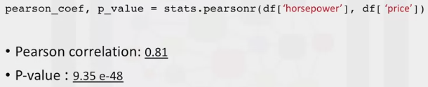

* 1. Strong positive correlation

1. Correlation Heatmap

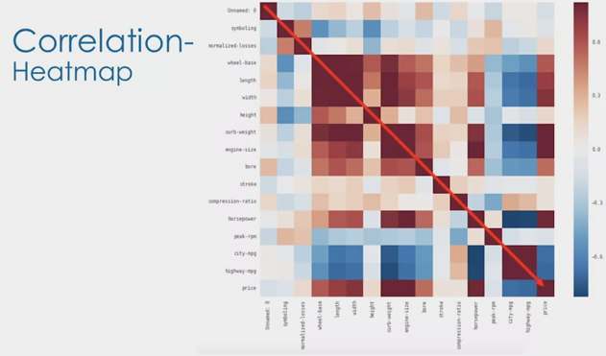

Chi-Square: Test for Association

1. Denoted as *x*2
2. Test intended to test how likely it is that an observation distribution is due to chance
3. Tests a null hypothesis that the variables are independent
   1. Compares observed data to the values that the model expects – if the data was distributed in different categories by chance
   2. Anytime the observed data doesn’t fit within the model of the expected values, the probability that the variables are dependent becomes stronger
4. Doesn’t tell you the type of relationship between variables, but only that a relationship exists
5. Expected values based on given totals: what can we say individual cells would be if we did not know the observed values?
6. (Row total*column total) / grand total

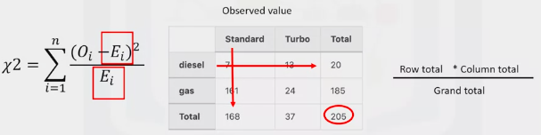

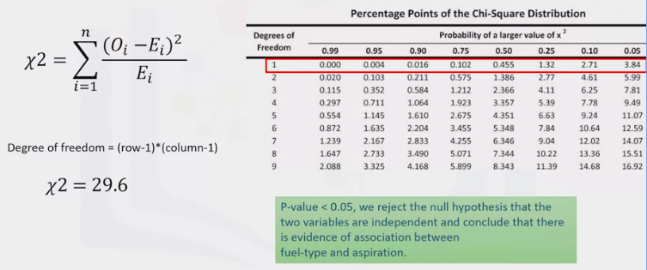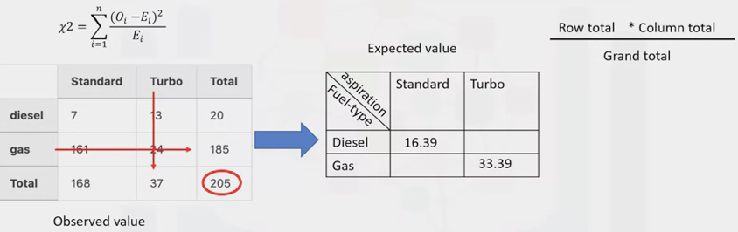

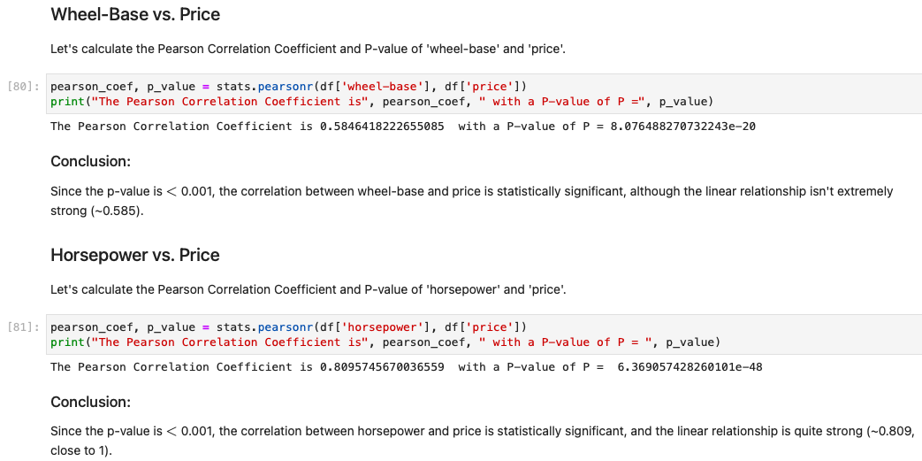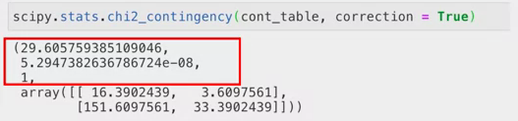

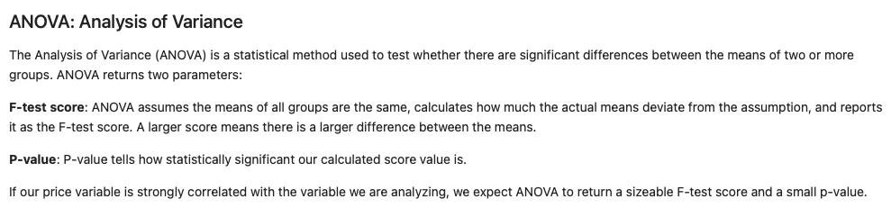

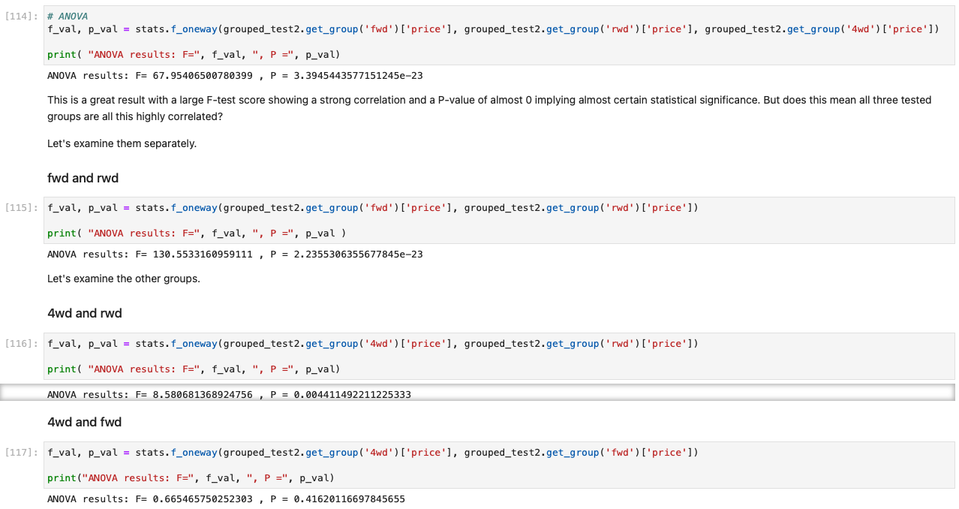

**MODEL DEVELOPMENT**

1. Model: Mathematical equation used to predict a value given one or more values
2. Relating one or more independent variables to dependent variables
3. Relevant data = more accurate result

Linear Regression and Multiple Linear Regression

1. Linear regression: One independent variable to make a prediction
2. Multiple Linear Regression: Multiple independent variables to make a prediction
3. Simple Linear Regression:

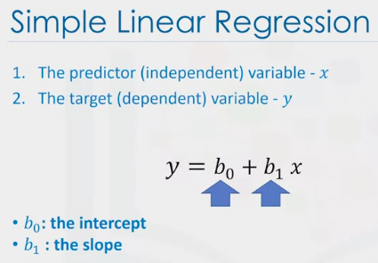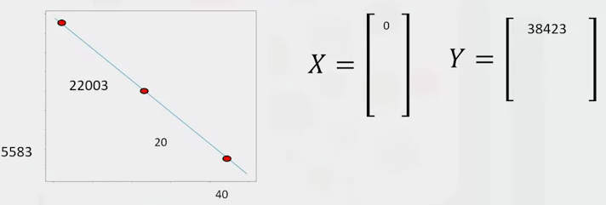

1. Datapoints (marked in red), then used to fit model, result are the parameters
2. Stored in two data frames or NP arrays
3. Small random ( + or -) value added to a point on the line: called noise
4. To create a model in Python:

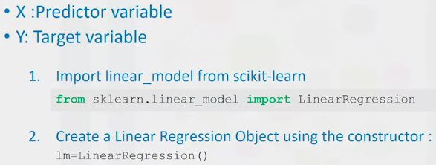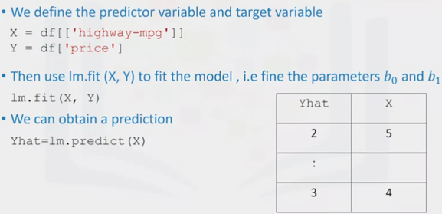

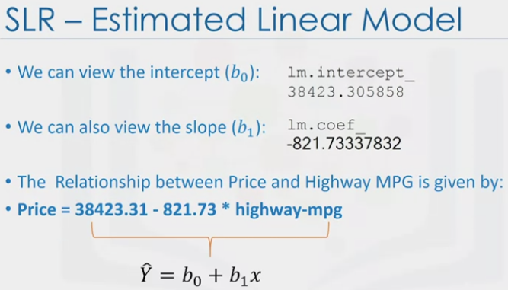

Multiple Linear Regression

1. Used to explain the relationship between:
   1. One continuous target (Y)
   2. Two or more predictors (X)

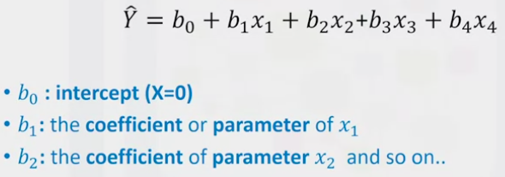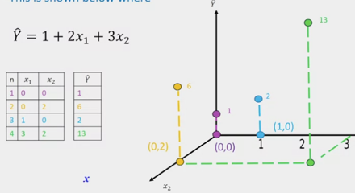

1. Fitting Multiple Linear Model Estimator
   1. Extract the 4 predictor variables and store them in the variable Z
      1. Z = df[[“horsepower”, “curb-weight”, “engine-size”, “highway-mpg”]]
   2. Train the model as before
      1. Lm.fit (Z, df[“price”])
   3. Obtain a prediction
      1. Yhat=lm.predict (x)

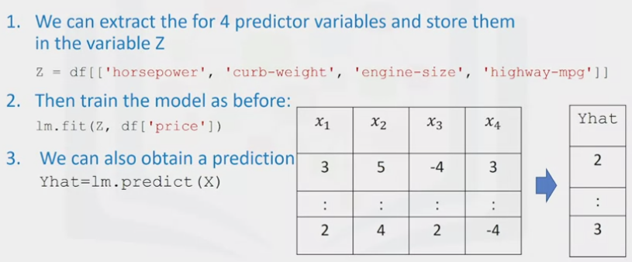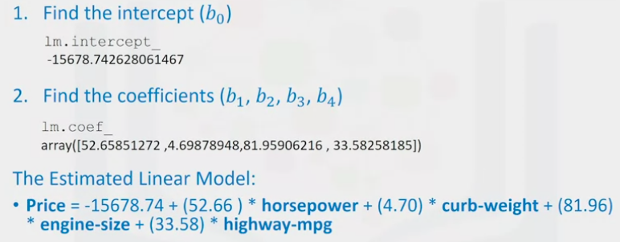

Model Evaluation Using Visualization

1. Regression Plot (sns.regplot)
   1. Relationship between two variables
   2. Strength of the correlation
   3. Direction of the relationship (pos or neg)

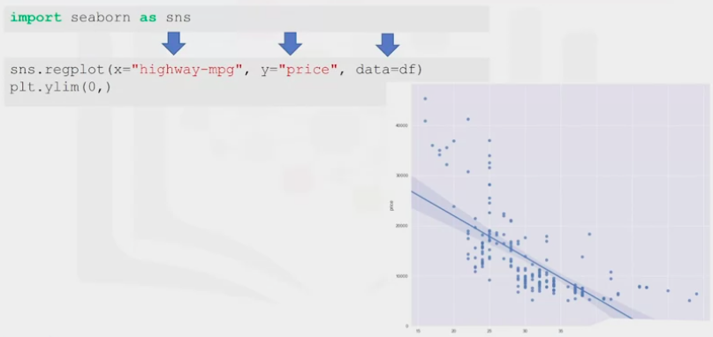

1. Residual Plot (sns.residplot)
   1. Represents the error between the predicted and actual value
   2. Obtain that value by subtracting the predicted value and the actual value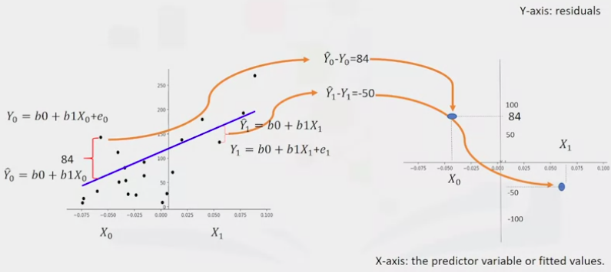

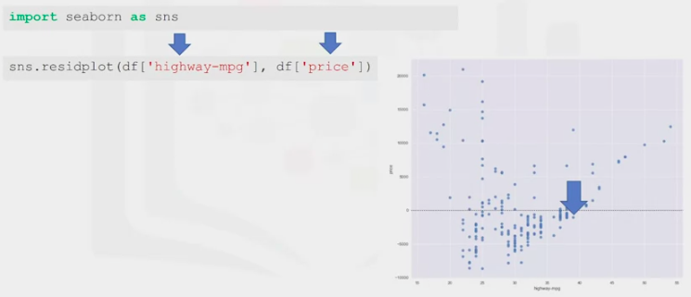Here we see the residuals have a curvature.

“high-way” = series of dependent variables or features.

“price” = target variable

1. Distribution Plot
   1. Useful for visualizing models with more than one independent variable
   2. Count predicted variables and target/actual values (red)

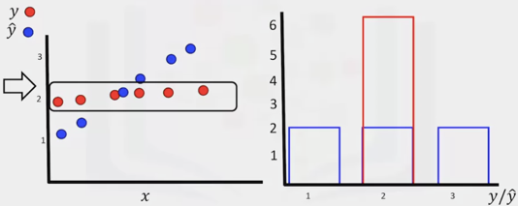 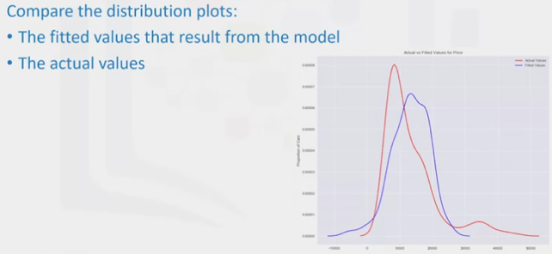

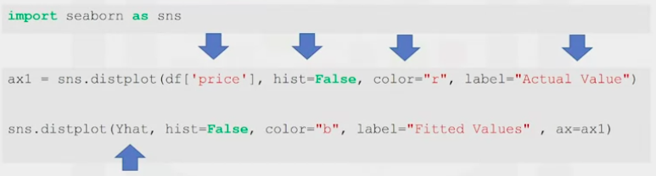

Polynomial Regression and Pipelines

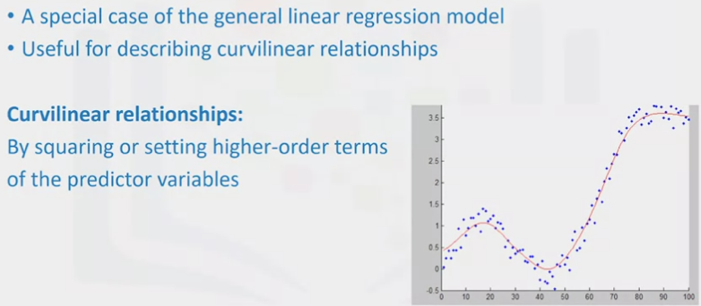

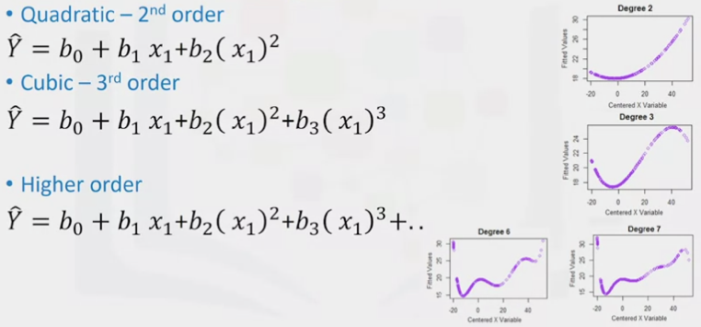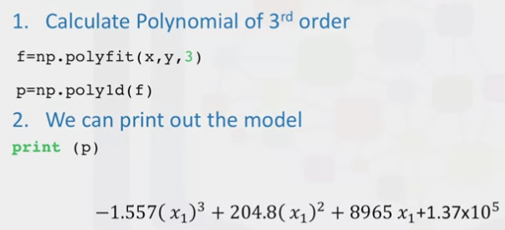

1. The preprocessing library in scikit-learn,
   1. from sklearn,.preprocessing import PolynomialFeatures
   2. pr=PolynomialFeatures(degree=2, include_bias = False)
   3. x_polly=pr.fit_transform(x[[“horsepower”, “curb-weight”]]

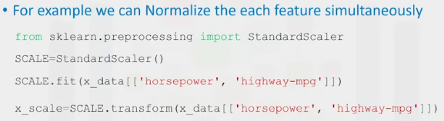

Pipelines

1. Simplify the code by using a pipeline library
2. Steps to getting a prediction:

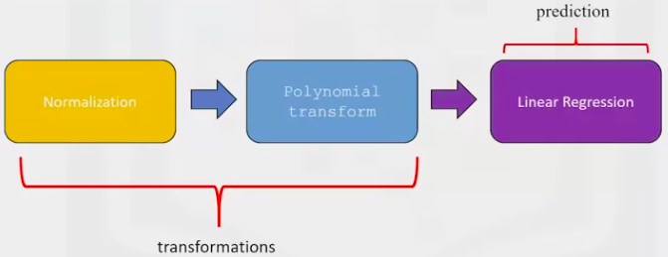

* 1. Import all the modules needed

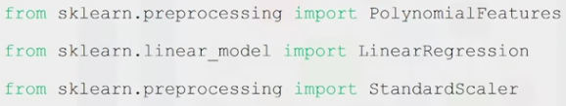

* 1. Import Pipeline



* 1. Create a list of tuples
     1. First element contains the name of the estimator (blue arrow)
     2. Second element contains model constructor (red arrow)
     3. Input the list in the pipeline constructor
     4. Pipe = pipeline object

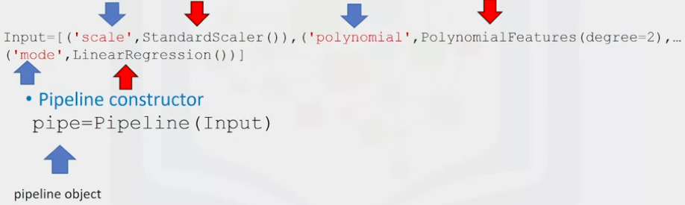

* 1. Train the pipeline (pipe.fit)
  2. Produce a prediction (yhat)
  3. Calculate R^2: pipe.score(x, y)

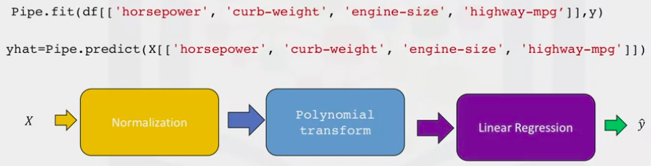

Measures for In-Sample Evaluation

1. Numerically determine how well the model fits the dataset
   1. Mean squared Error (MSE)
   2. R-Squared
2. MSE
   1. Find the difference between the actual value -Y and the predicted value Y-hat and square it

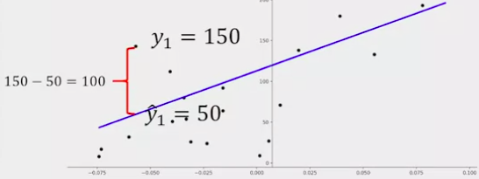 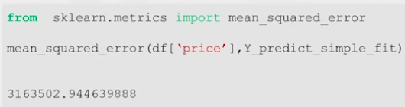

* 1. Two inputs: Actual value of target variable and the predicted target variable

1. R-squared (Coefficient of Determination or R^2)
   1. Measures how close the data is to the fitted regression line
   2. R^2: Percentage of variation of the target variable (Y) explained by the linear model

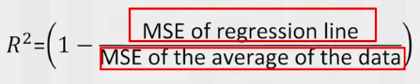

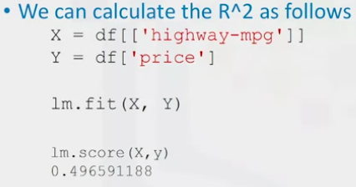

Prediction and Decision Making

1. Do the predicted values make sense?
   1. Visualization
   2. Numerical Measures for Evaluation
   3. Comparing Models
2. Test Predicted Values

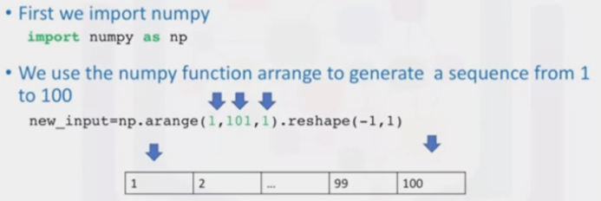

1. Mean Square Error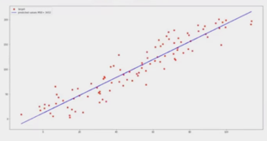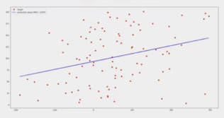
   1. As the square error increase, the targets get further from their predicted points
2. R^2 Model

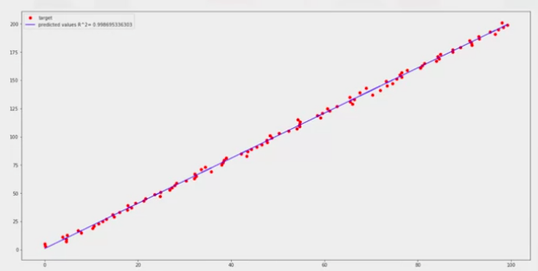

R^2: 0.99826 – A good fit. 99% of the variability is explained by the independent variable

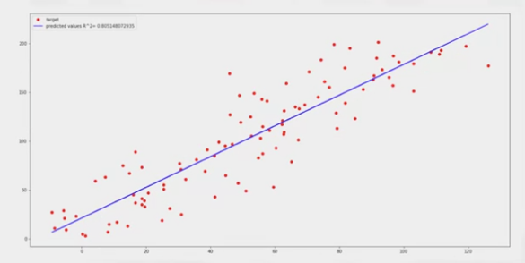

R^2: 0.806 – 80% of the variability of the variables is explained by the independent variable

* 1. An acceptable value depends on the field you are studying and what your use case is
  2. Miller: acceptable R^2 should be 0.1

1. Does a lower Mean Square Error imply better fit?
   1. Not necessarily
   2. Mean Square error for a MLR model will be smaller than for a SLR, since the errors decrease when more variables are included
   3. Polynomial regression will also have a smaller MSE than linear regular regression

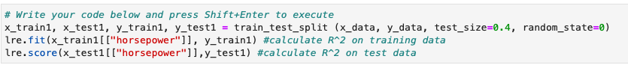

**MODEL EVALUATION AND REFINEMENT**

1. In-sample evaluation tells us how well our model will fit the data used to train it
2. Does not tell us how well the trained model can be used to predict new data
   1. Solution: In-sample data or training data
   2. Out-of-sample evaluation or test set

Testing/Training Sets

1. Split data into:
   1. 70% training set
   2. 30% testing set
2. Build and train model with a training set – discover predictive relationships
3. Use testing set to assess the performance of a predictive model
4. Use all the data to test completed model

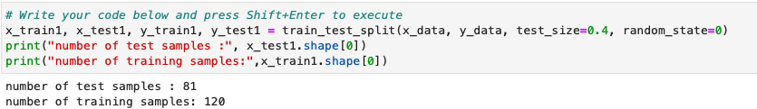

Function Train_test_split()

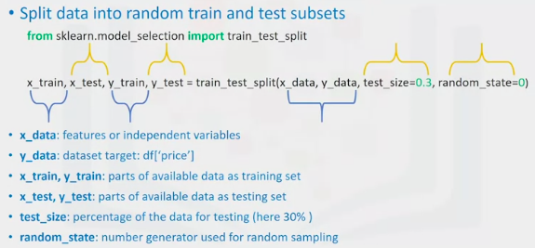

Generalization Performance

1. Generalization error is a measure of how well the data does at predicting previously unseen data
2. The error obtained using testing data is an approximation of this error

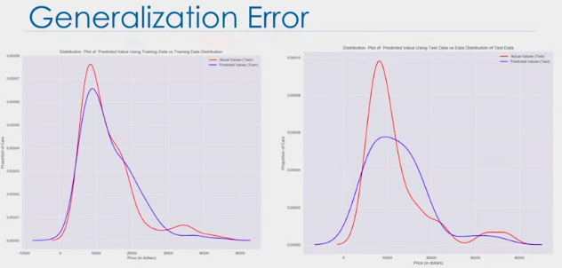

Left is the test data – represents what we see in the real world  
3. If we use fewer data points to train the model and more to test the model – the accuracy of the generalized data performance will be less. To correct this we use cross validation.

Cross Validation

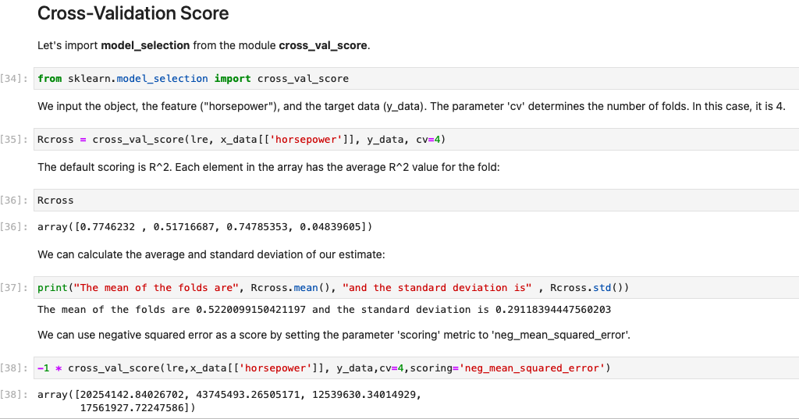

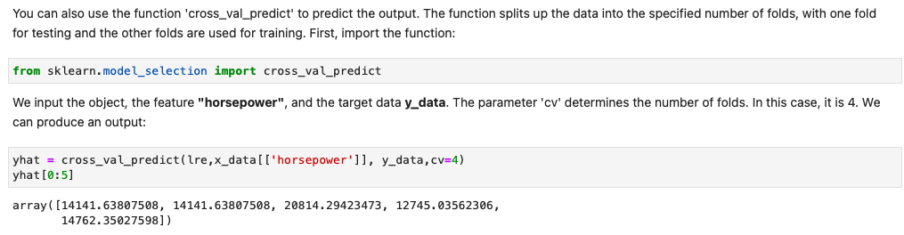

1. Most common “test data” (or: out-of-sample data) evaluation metrics

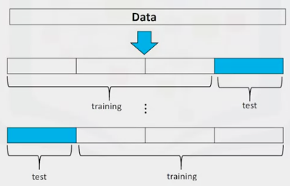Data is split into K=groups. Each group is referred to as a fold. Folds are divided into training folds and testing folds.

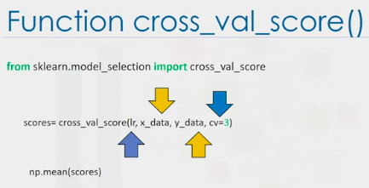“lr”: Linear Regression model

“x_data”: Predictor

“y_data”: Target

“CV”: Number of partitions

NP.mean(scores): Estimate out-of-sample R^2

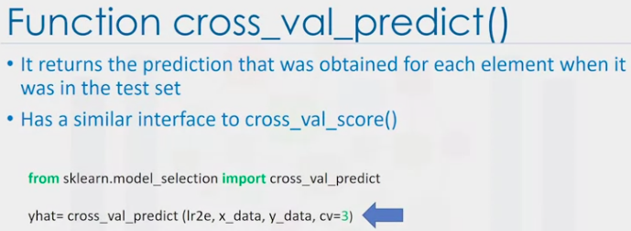

Over-Fitting, Underfitting and Model Selection

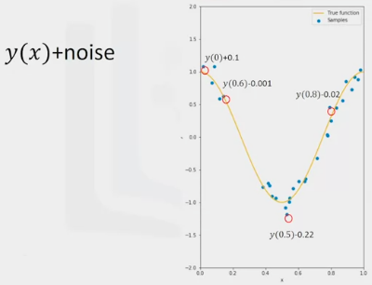Goal of model selection is to detrmine the order of the polynomial to provide the best estimate of the function Y(x).

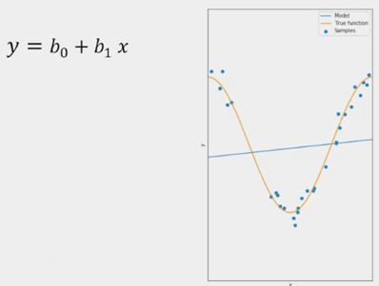A linear model is not complex enough to fit the data.

Increase the order of the polynomial the model fits better, but is still not flexible enough and exhibits under-fitting.   
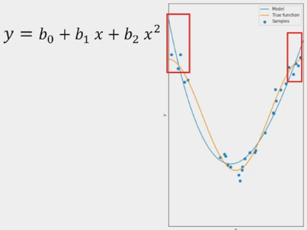

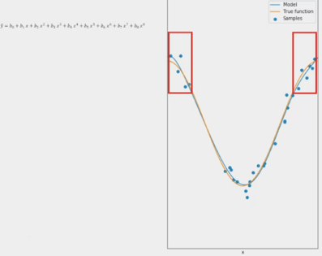8th order polynomial – fits well even at inflection points

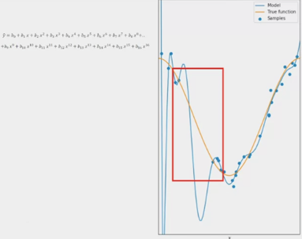16th order polynomial does well to track the training point, but performs poorly where there is little training data. Overfitting – fits the noise rather than the function

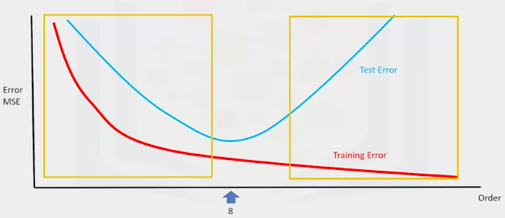Left: Under-fitting. Right: Over-fitting

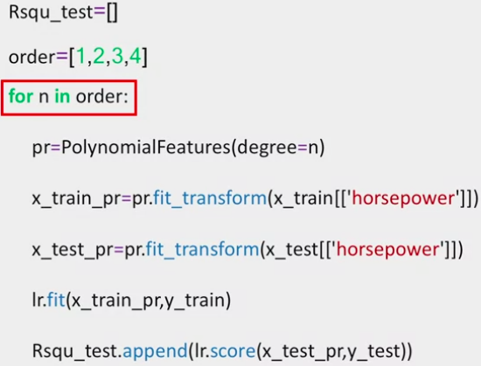

1. Create empty list to store values
2. List containing dif polynomial orders
3. Iterate through the list using a for loop
4. Create a polynomial feature object with the order of the polynomial as a parameter
5. Transform the test/training data into a polynomial using fit_transform method
6. Fit regression model using transformed data
7. Calculate the R^2 using the test data. Store it in the array.

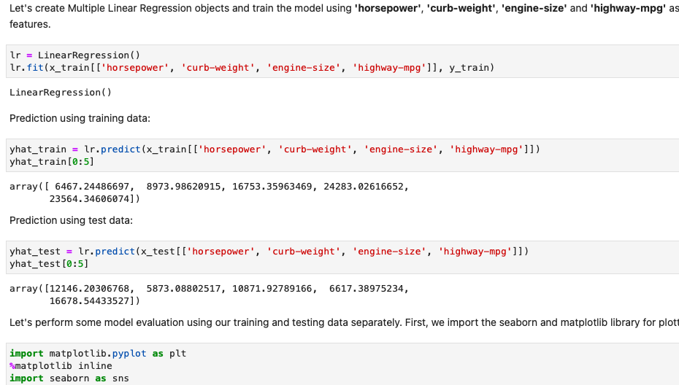



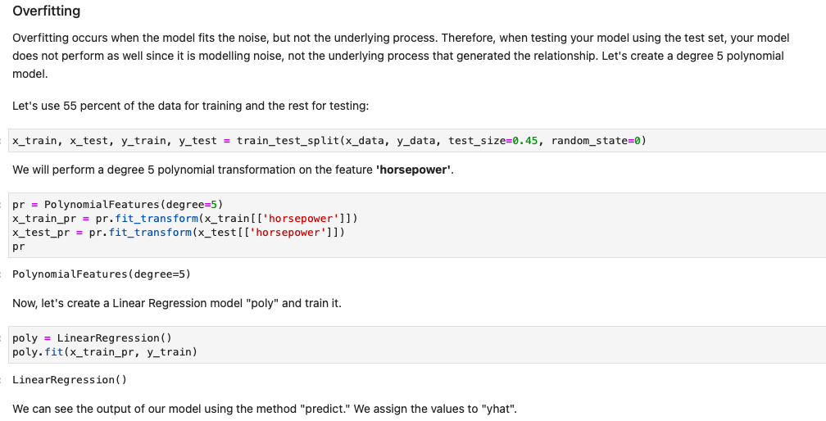

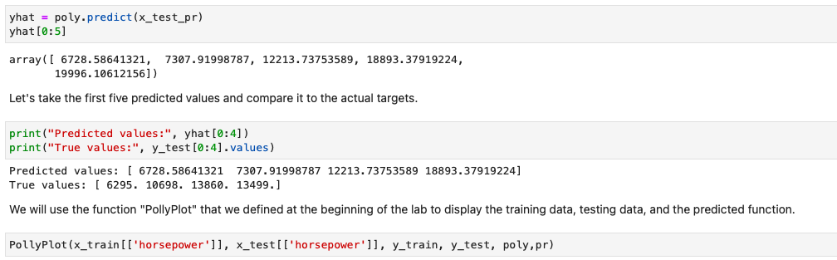

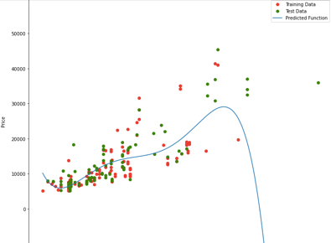Polynomial regression model where red dots = training data, green dots = test data, blue line = model prediction

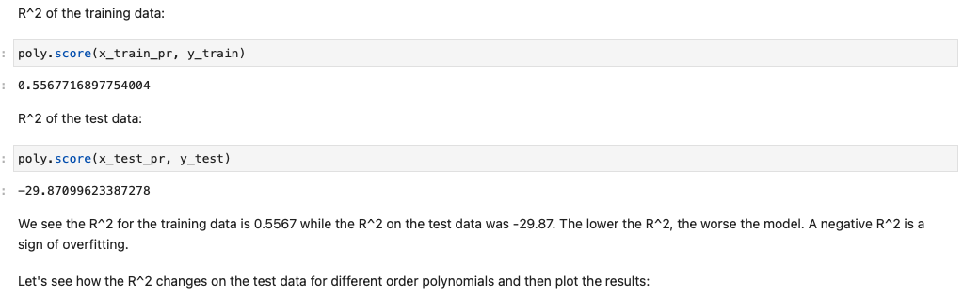

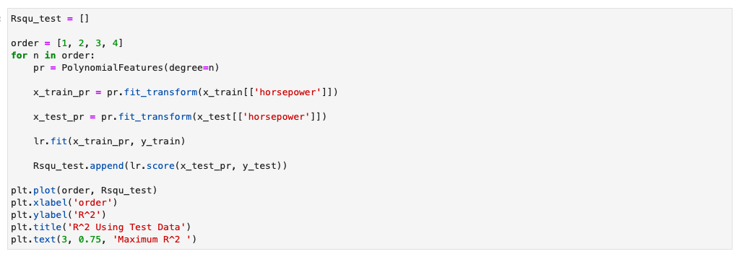

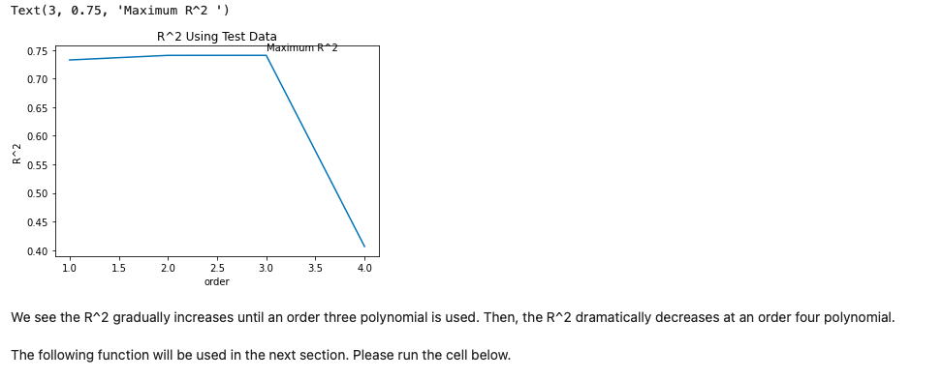

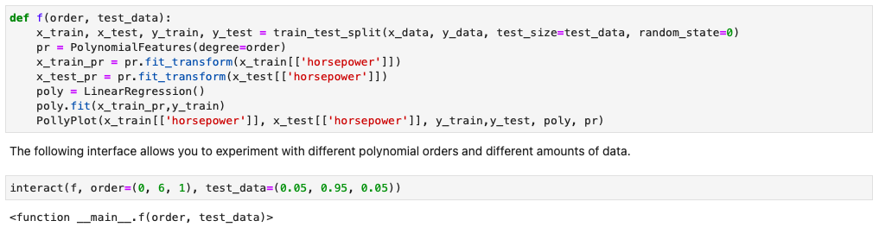

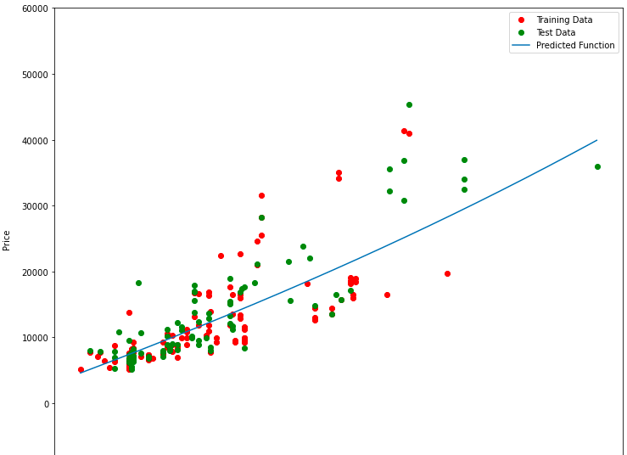

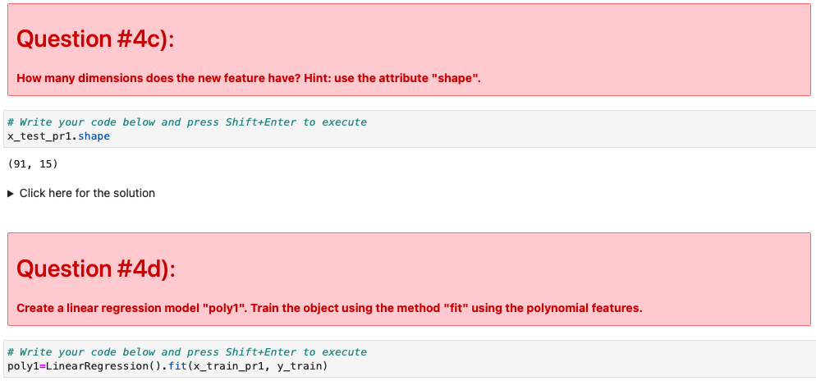

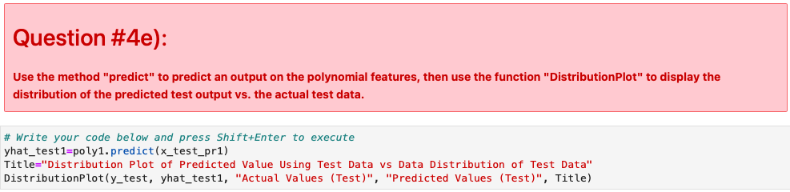

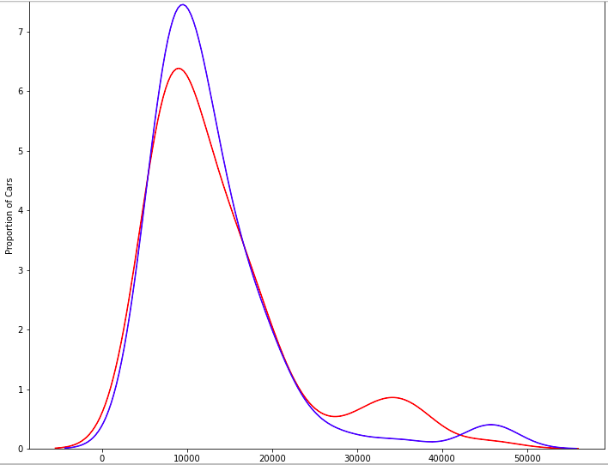

Ridge Regression Introduction

1. A regression that is employed in a multiple regression model when multicollinearity occurs
2. Multicollinearity: Strong relationship among the independent variables
3. Prevents over-fitting

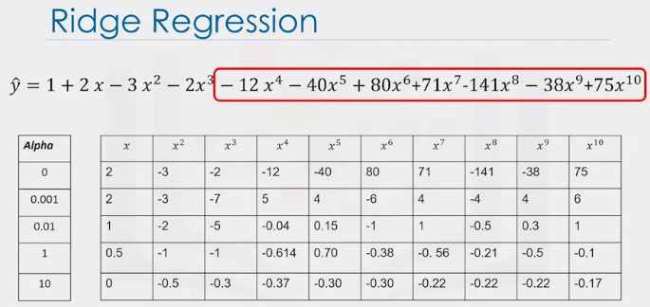Estimated polynomial coefficients have a very large magnitude. Evident with the higher order polynomials.

Ridge Regression controls the magnitude of the polynomial coefficients by introducing Alpha. Alpha is chosen before fitting the model.

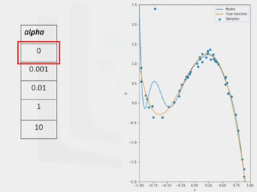 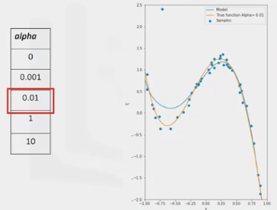 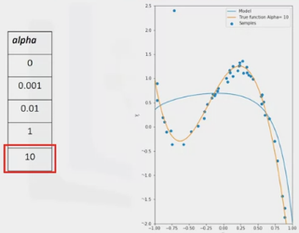

Over-fitting Tracking Under-fitting

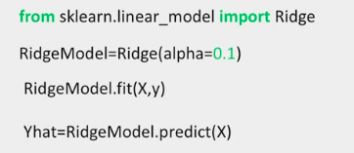

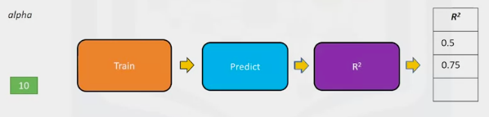

1. Use data for training. Use a second set called validation data (predict)
2. Start with a small value of alpha – train – predict – store value of R^2

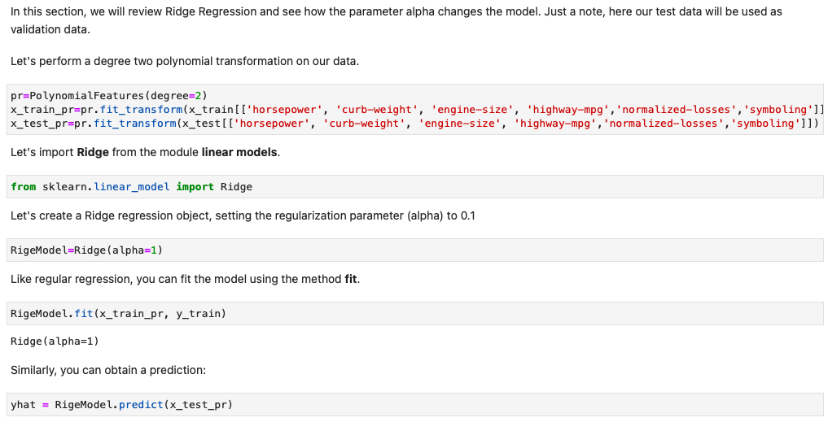

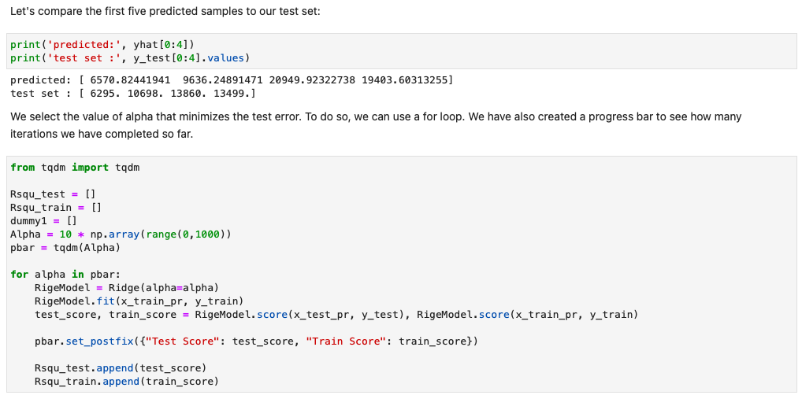

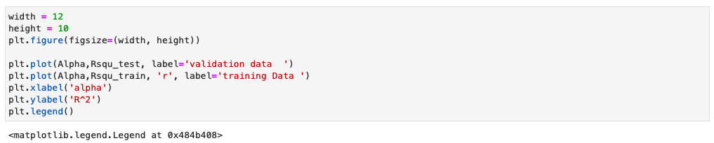

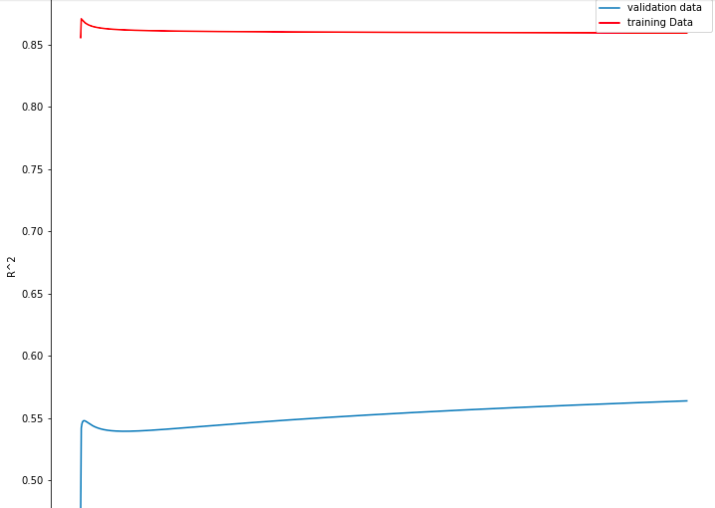

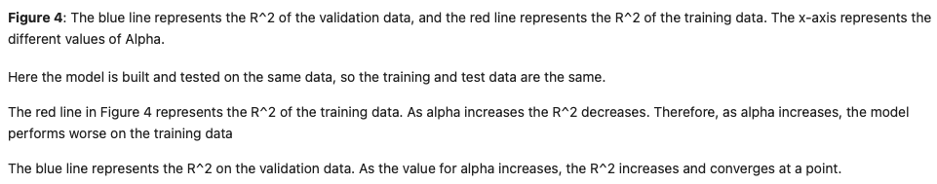

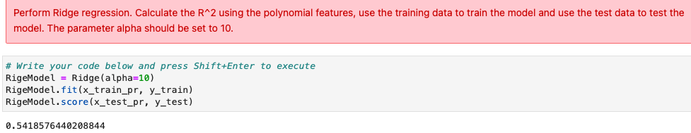

Grid Search

1. Allows scanning of multiple free parameters with only a few lines of code

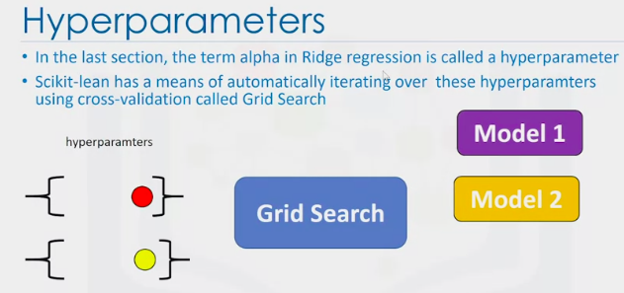

1. 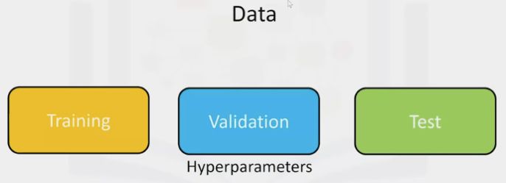 Train model for dif hyperparameters – R^2 used for each model
2. Select hyperparameters on the validation set
3. Test model

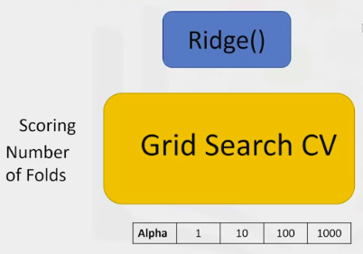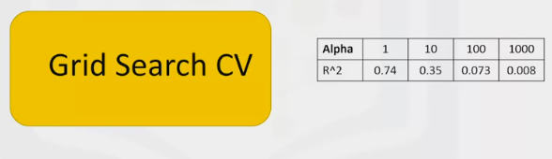

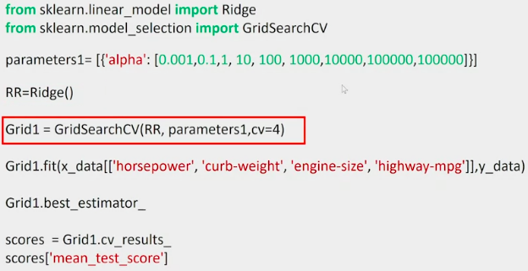

1. GridsearchCV: dictionary of parameter values
2. Create a Ridge Regression (RR) object or model
3. Create a GridSearch CV object (inputs: RR object, parameters, number of folds)
   1. Use R^2 – default scoring method
4. Fit the object
5. Find the best values for the free parameters using the best_estimator attribute
6. Get the mean score on the validation data using cv_result

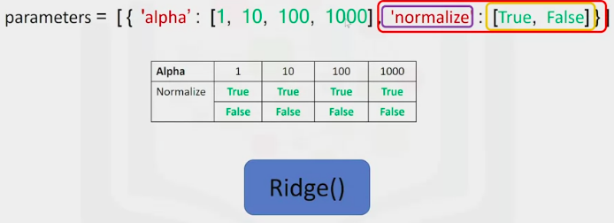Ridge Regression object or model

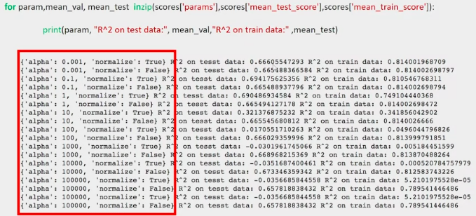

Print the score for the dif free parameter values

